**Final Exam**

BUAD352 – Spring 2022

Section 2

______________________________________________________________________________

1. **Objectives**

The purpose of this assessment is to give you an opportunity to show a clear understanding of the skills you have learned in this class.

1. **What You Will Need**

Access to a computer with Excel 365.

A workbook named Final.xlsm, downloadable from the class web site.

1. **What You Will Hand In**

Submit the workbook that you create (Final*FirstnameLastname*.xlsm) via Blackboard - Final.

1. **Due Date**

Tuesday March 22nd, 2022. You have 1 hour and 20 minutes.

1. **Note on Collaboration**

This is a Category A assignment. Specifically, you may not receive help from anyone on this assignment except the professor or teaching assistant. It must be 100% your own work. All questions concerning this assignment must be addressed to your professor or the teaching assistant. *It is an honor code offense to give or receive any assistance on these assignments*. Your personal class notes are allowed. DO NOT SHARE THIS EXAM!

1. **Honor Code**

The Pledge: "As a member of the William and Mary community, I pledge on my honor not to lie, cheat, or steal, either in my academic or personal life. I understand that such acts violate the Honor Code and undermine the community of trust, of which we are all stewards."

**Requirement: Go to the “HonorCode” worksheet. Insert a text box and type in the honor code pledge. Sign your name at the bottom.**

**Failure to complete this requirement will result in a 20% deduction on your final exam grade.**

**Problem 1 (50%): Dynamic Tables and Graphs**

Replicate the following spreadsheet in the worksheet named “Problem1.”

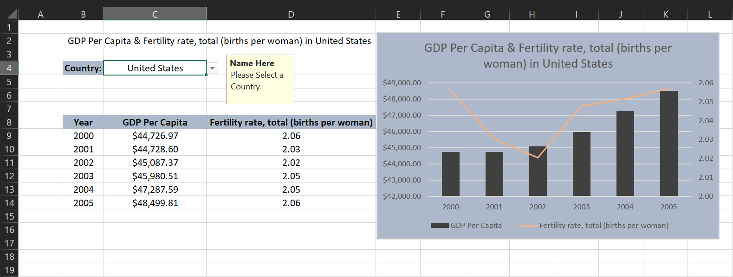

Rules:

* Cell C4 must be a data validated field (list). Each country must appear only once in the list.
* The table in the range B8:D14 must be linked to the data validated field C4. When the country selected changes, the table should update with the correct values.
* The numbers for GDP Per Capita should be retrieved from the worksheet “WDI” by using the function sumifs().
* The numbers for Fertility Rate should be retrieved from the worksheet “WDI2” by using the match() and offset() functions.
* The title in cell B2 must combine the text in C8, D8 and C4. It should reference these cells.
* The graph should be a dual axis chart that displays GDP per capita as columns and the Fertility Rate as a line.
* Axis and Labels must match the screenshot. However, you are free to choose your own colors.
* The title of the graph should link to cell C4.
* When the C4 cell is selected, a message box should appear to the right with your name (bold) and the message “Please Select a Country.”
* Changing the country in cell C4, should update the graph.

*Note: Each bullet point is worth 5 percentage points.*

**Problem 2 (20%): Nested Loops**

Create the pattern below using VBA.

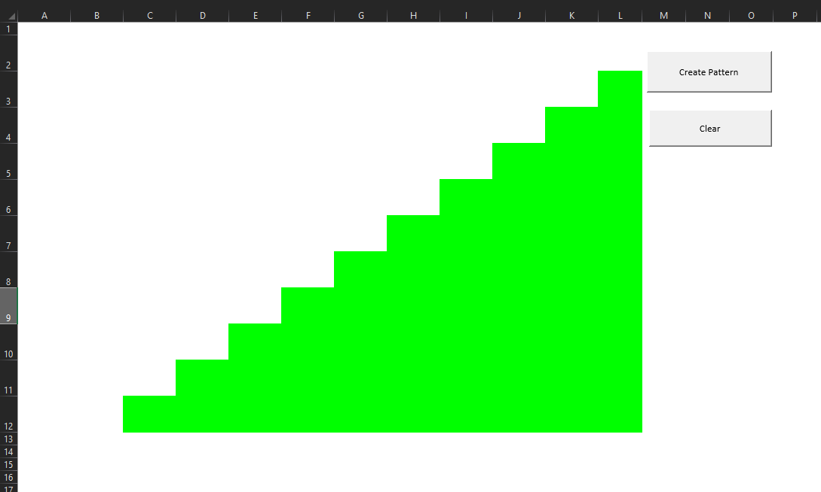

Rules:

* The pattern must be constructed with VBA and the use of a nested loop.
* The range of the pattern must be B2:L12
* The pattern should be created with a button. The caption should be “Create Pattern”.
* The pattern should be cleared by pressing a button. The caption should be “Clear”. This does not require a loop.

*Note: Each bullet point is worth 5 percentage points.*

**Problem 3 (30%). Loops and Conditionals**

Create VB code simulates ratings.

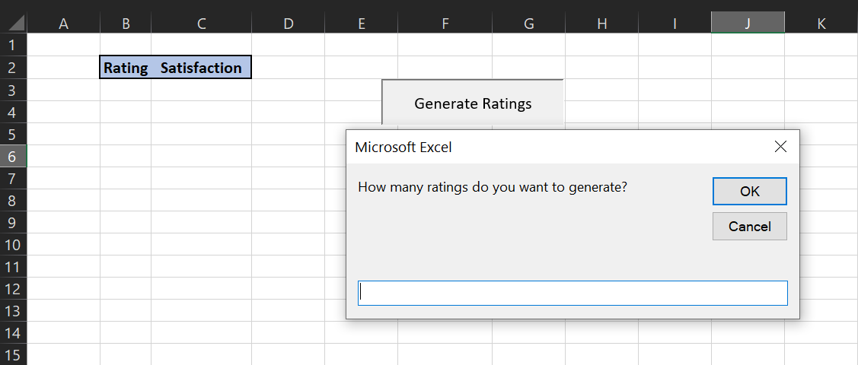

Rules:

* A button should activate the Macro. The caption on the button should be “Generate Ratings”
* An Input box should launch prompting the user to specify the number of ratings to generate. “How many ratings do you want to generate?”
* Ratings are a number between 0 and 1 (you can use the rnd() function in VB). The first rating should be placed in cell B3 (all other should be directly below).
* Generate a satisfaction value. If the rating is 0.9 or above the satisfaction is “Very Satisfied” and the color of the cell is RGB(234, 235, 242). If the rating is below 0.9 and 0.7 or above the satisfaction is “Satisfied” and the color of the cell is RGB(210, 221, 232). All ratings below 0.7 are classified as “Not Satisfied” and the color of the cell is RGB(185, 202, 222).
* A message box should appear after the macro is complete. It should read “These values were generated by *Your Name*” where you replace *Your Name*, with your first name and last name.
* Whenever the Macro is run, the table should clear itself. (Do not create a separate macro for this). This procedure should be done at the beginning of the macro.

*Note: Each bullet point is worth 6 percentage points.*

